
Jorhat Engineering College Department of Mechanical Engineering B.Tech. (Mechanical Engineering) Spring Semester 2025

ACADEMIC INTERNSHIP REPORT
Design and Analysis of a Total Ossicular Replacement Prosthesis (TORP)

Submitted by:
Sandeep Roy (Roll No.: 230710102098) B.Tech. Mechanical Engineering
Jorhat Engineering College

Guide:
Dr. Apurba Das
Professor, Department of Mechanical Engineering
Indian Institute of Engineering Science and Technology, Shibpur


Department of Mechanical Engineering
Indian Institute of Engineering Science and Technology, Shibpur (Formerly Bengal Engineering and Science University, Shibpur)
P.O. Botanic Garden, Howrah-711103, West Bengal, India
+91-033 2668-4561 to 63, Fax: 91-00-2668-7575/2916

Date: 01.09.2025

TO WHOM IT MAY CONCERN

This is to certify that Mr. Sandeep Roy, student of Mechanical Engineering Dept, Jorhat Engineering College (Roll No 230710102098) has successfully completed online internship from 1st July 2025 to 31st July 2025 under my guidance. During his tenure, Mr. Roy has successfully performed the model of torp prosthesis of human ear and performed analysis of the same.


I wish him success in his future endeavor. With warm regards,


Dr. Apurba Das
Assistant Professor & Faculty member of DTPC Department of Mechanical Engineering
Indian Institute of Engineering Science and Technology, Shibpur Howrah, 711103, West Bengal, India, Phone: 033-26684561-64 Institute Profile https://www.iiests.ac.in/IIEST/Faculty/mech-apurbadas
Google Scholar: https://scholar.google.com/citations?hl=en&user=IXCqkoIAAAAJ Email: apurbadas@mech.iiests.ac.in, apurbadas.mech@faculty.iiests.ac.in

DECLARATION

I, Sandeep Roy, declare that the work presented in this report entitled “Design and Analysis of a Total Ossicular Replacement Prosthesis (TORP)” is my own work carried out under the guidance of Dr. Apurba Das during my internship at IIEST Shibpur. This work has not been submitted to any other institution for the award of any degree or diploma.

Signature:  Date: 05-09-2025

ACKNOWLEDGEMENT

I sincerely thank Dr. Apurba Das for his valuable guidance and continuous encouragement throughout the internship. His insights in simulation methodology and biomedical device design helped me complete this project successfully.
I am also grateful to the Department of Mechanical Engineering, IIEST Shibpur, for providing the necessary computational resources. I extend my sincere thanks to my home institute, Jorhat Engineering College, especially to our Principal Dr. Rupam Boruah and the Head of the Department of Mechanical Engineering, Dr. Diganta Hatibaruah, for their encouragement and support in allowing me to undertake this academic internship.
Finally, I acknowledge the support of my friends and family for their constant motivation.

ABSTRACT

This report presents the design and computational evaluation of a Total Ossicular Replacement Prosthesis (TORP), developed as part of a summer internship in mechanical engineering. TORPs are critical biomedical implants used to restore conductive hearing loss by replacing the damaged ossicular chain in the middle ear. The aim of this project was to design a structurally safe and dynamically stable prosthesis using computer-aided engineering tools.
The work was carried out in three stages: (1) computer-aided design (CAD) of the prosthesis using Autodesk Fusion 360, (2) finite element–based static stress analysis under acoustic- equivalent loading, and (3) modal analysis to identify natural frequencies and associated mode shapes. Titanium alloy Ti-6Al-4V, a clinically established implant material, was selected for the study owing to its high strength-to-weight ratio and proven biocompatibility.
The static stress analysis applied a force of 5.0 × 10⁻⁵ N and a pressure of 1 × 10⁻⁶ MPa, representing conservative acoustic excitation. The results indicated an extremely small maximum displacement of 3.339 × 10⁻⁹ mm and a peak von Mises stress of only 3.378 × 10⁻⁵ MPa, with the minimum safety factor calculated as 15.0. These values confirm that the prosthesis behaves almost rigidly under physiological loading conditions and is far from any structural failure risk.
The modal analysis, conducted with eight eigenmodes, identified natural frequencies spanning from approximately 7.4 kHz to 188 kHz. Importantly, all modes were found to lie outside the critical auditory frequency band of 100–6000 Hz. This implies that the prosthesis will not undergo resonance within the range relevant to human hearing, thereby ensuring stable functional performance.
Overall, the analyses confirm that the designed TORP is both mechanically robust and dynamically reliable. The findings provide a strong foundation for future steps, including prototype fabrication, in-vitro testing, and eventual clinical evaluation.

TABLE OF CONTENTS

Chap. No. Chapter Name. Page

Certificate i
Declaration ii
Acknowledgement iii
Abstract iv
- Objectives of Internship 2
- Introduction 3
- Literature Review and Rationale 5
- CAD Model and Pre-Processing 7
- Material Selection and Properties 10
- Simulation Methodology 12
- Results 14
- Discussion 29
- Limitations and Future Considerations 30
- Ethical, Safety and Regulatory Considerations 32
Conclusion 34
Recommendations for Future work 35
References 36

CHAPTER 1

OBJECTIVES OF THE INTERNSHIP

- To conceptualize and develop a precise CAD model of a Total Ossicular Replacement Prosthesis (TORP) using Autodesk Fusion 360.
- To select an appropriate biocompatible material, specifically Ti-6Al-4V, and incorporate its validated mechanical properties into the model.
- To conduct a static stress analysis simulating acoustic-equivalent loading conditions in order to assess structural integrity.
- To perform modal frequency analysis for identifying the natural frequencies and associated mode shapes of the prosthesis.
- To evaluate the mechanical safety, durability, and vibrational stability of the design with respect to clinical auditory requirements.
- To compile the findings in a structured engineering report that adheres to academic and professional standards.

CHAPTER 2

INTRODUCTION

Hearing is among the most critical senses for human quality of life and communication. Sound waves entering the ear canal induce vibrations in the tympanic membrane (eardrum), which are passed on by a series of three little bones in the middle ear — the malleus, incus, and stapes. The ossicular chain is a mechanical amplifier, efficiently transferring sound energy from air to the fluid-filled cochlea of the inner ear.
When this ossicular chain is broken by chronic ear infections (otitis media), trauma, cholesteatoma, or congenital anomalies, the effective transfer of sound is lost. Such a condition, or conductive hearing loss, does not allow sound vibrations to pass to the inner ear effectively, even when the cochlea itself is intact. Patients with conductive hearing loss have diminished ability to hear, and this can significantly impair communication, education, and quality of life.
One of the well-established surgical treatments for such a condition is the placement of an ossicular replacement prosthesis. In the event of loss or damage to the entire ossicular chain, a Total Ossicular Replacement Prosthesis (TORP) is placed between the tympanic membrane and the stapes footplate (oval window). The TORP successfully replaces the natural ossicles and restores continuity in the mechanical transmission pathway.
For proper functioning of such implants, there are a number of essential requirements to be fulfilled:
Biocompatibility: The material should not be toxic or cause rejection.
Mechanical Stability: The prosthesis must not deform when subjected to typical acoustic loads.
Dynamic Reliability: The implant should escape resonances in the human hearing frequency range (100–6000 Hz), since resonances would distort the sound transmission and lower hearing quality.
Surgical Suitability: The design must facilitate stable installation, low trauma, and ready handling in surgery.
In contemporary biomedical engineering, numerical analysis is a must before fabrication and use in clinical applications. Finite Element Analysis (FEA) enables the engineer to predict how the prosthesis would perform under physiological loading, estimate stress concentrations, and determine natural frequencies. This minimizes the potential of design failure, speeds up the development cycle, and offers valuable verification before expensive prototyping.
Throughout this internship, the goal was to model a TORP in Autodesk Fusion 360 and analyze its structural and vibrational behavior through simulation. The work was particularly centered around:
- Construction of a CAD model based on anatomical and surgical limitations.
- Static stress analysis to confirm structural integrity under an acoustic-equivalent force.

- Modal frequency analysis to check if natural frequencies occur outside the critical range of hearing.
With this work, an engineering basis for a safe, reliable design of a prosthesis suitable for prototyping and ultimately clinical verification has been laid.

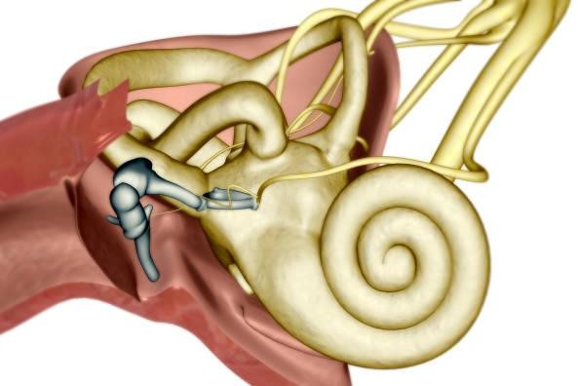
Fig: Anatomical illustration of the human inner ear showing the cochlea, semicircular canals, and the auditory ossicles (malleus, incus, and stapes) within the middle ear.
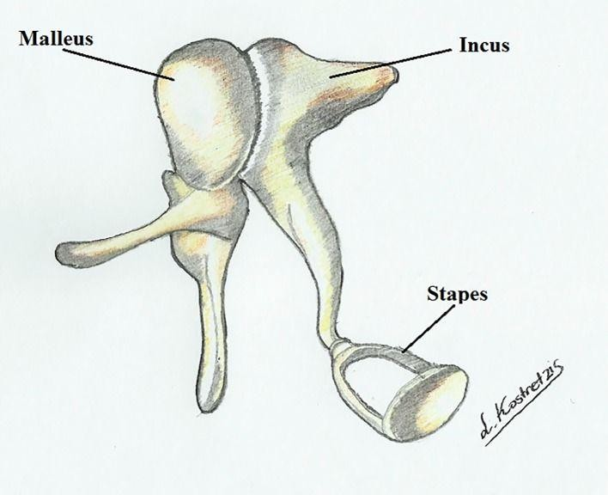
Fig: Diagram of the auditory ossicles—the malleus, incus, and stapes—which form the chain of small bones in the middle ear responsible for transmitting sound vibrations from the eardrum to the inner ear.

CHAPTER 3

LITERATURE REVIEW AND DESIGN RATIONALE

The prosthetic design of ossicles has been a field of vigorous research for decades, aiming at recovery of hearing in patients with conductive hearing loss. Materials and geometrical configuration have been explored, each of them with some benefits and drawbacks.

Material Selection:
Among the numerous materials that have been researched, titanium alloys, and especially Ti- 6Al-4V, have become the gold standard in clinic. Titanium provides a very high correlation of properties: a high strength-to-weight ratio, resistance to corrosion, and biocompatibility, which makes it suitable for long-term implantation. Its relatively low density is such that the prosthesis will add negligible mass to the middle ear system, with no interference in natural vibration transmission. Alternative materials like hydroxyapatite and ceramics are of good biocompatibility but are brittle, while precious metals and stainless steels, although being strong, are heavier and less desirable in dynamic performance. For the same reasons, Ti-6Al- 4V was chosen in the present study as the material for simulation and design validation.

Design Features:
A standard Total Ossicular Replacement Prosthesis (TORP) has three main regions: a stem, a footplate, and a head. The footplate needs to sit on the stapes footplate (oval window) and needs to transfer load without generating excessive local stresses that will harm adjacent tissue. The stem needs to achieve the required length and stiffness with a minimum cross-sectional area to keep mass low. The head needs to interface with the tympanic membrane or graft and needs to transfer load effectively and make stable contact. Careful transition shaping, such as with fillets and radii, is essential to prevent stress concentration. Additionally, manufacturability is a consideration since very complex geometries are potentially unproducible to medical-grade tolerances. The design for this project had these features in mind, with a stable yet thin stem and smoothly transitional shapes to provide structure while being practical for manufacturing.

Clinical Relevance:
Clinically, the prosthesis will not only have to survive mechanical stresses but also be in harmony with the auditory system. The human auditory range is generally 100 Hz to approximately 6000 Hz for speech and everyday conversations, even though greater frequencies are detectible. If the prosthesis has a natural frequency (resonance) within this spectrum, it may distort sound conduction, resulting in degenerate hearing results or pain. Therefore, a critical element of the design reasoning is to guarantee that natural frequencies of the prosthesis are well beyond the range of audibility. Modal analysis thus becomes a central component of design verification, complementing static analysis by offering knowledge of the dynamic response of the implant.
In combination, the selection of titanium alloy and the use of a geometrically simple but biomechanically rational design align with the practice of clinical medicine and engineering.

The intent is to produce a prosthesis that is safe, effective, and producible and to reduce the risks of mechanical failure or resonance-mediated performance degradation.

CHAPTER 4

CAD MODEL AND PRE-PROCESSING

The TORP geometry was designed in Autodesk Fusion 360 with dimensions chosen to ensure compatibility with the anatomical constraints of the middle-ear cavity. The design consists of three main functional regions:

Footplate (Base):
  - Width: 3.6 mm
  - Length: 3.6 mm (approximately circular)
  - Thickness: 0.2 mm
  - Function: Provides stable contact with the stapes footplate (oval window).
  - Design Considerations: Thin but wide enough to distribute load effectively. Rounded edges were applied to reduce stress concentrations and avoid trauma to adjacent tissue.

Shaft (Stem):
  - Length: 5.35 mm
  - Diameter: ~0.5 mm (optimized during modeling for stiffness-to-mass ratio)
  - Function: Connects the footplate with the head, transmitting loads.
  - Design Considerations: Long enough to span the anatomical gap, yet slender to minimize mass. Fillets were added at both ends to reduce stress concentrations.

Head/Cap:
  - Diameter: ~2.5–3.0 mm
  - Thickness: ~0.3 mm
  - Function: Provides contact with the tympanic membrane or ossicular graft.
  - Design Considerations: The surface was modeled as flat and smooth to ensure stable coupling and avoid pressure points.

Geometric Optimization and Clean-up:
- Tiny features and sliver faces were removed to ensure mesh stability.
- Smooth fillets were introduced at shaft–footplate and shaft–head junctions.
- Dimensions were cross-checked to remain manufacturable by precision machining or additive manufacturing methods.

- Units were standardized in millimetres to maintain consistency across CAD and FEA workflows.

Component | Dimension | Value
Footplate | Width/Length | 3.6 mm
Footplate | Thickness | 0.2 mm
Shaft | Length | 5.35 mm
Shaft | Diameter | ~0.5 mm
Head | Diameter | 2.5–3.0 mm
Head | Thickness | ~0.3 mm

Table 1: Key Geometric Parameters of TORP

The resulting geometry is compact, lightweight, and mechanically robust, balancing clinical requirements, mechanical performance, and manufacturability.

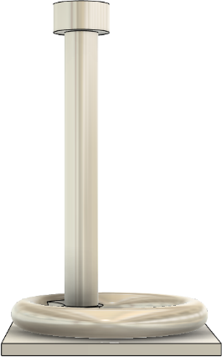

Fig 1: Side View of TORP Model

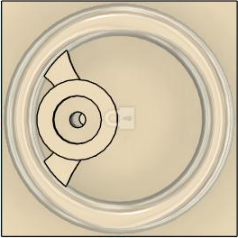

Fig 2: Top View of TORP Model
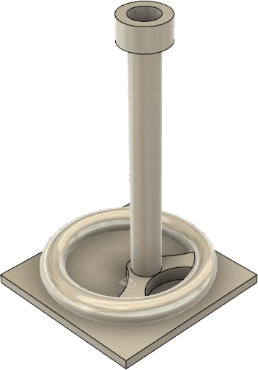

Fig 3: Isometric View of TORP Model

CHAPTER 5

MATERIAL SELECTION AND PROPERTIES

The prosthesis was assigned Ti-6Al-4V (Grade 5 Titanium Alloy), which is one of the most widely used biomedical materials for load-bearing implants. It combines high mechanical strength with low density, excellent corrosion resistance, and long-term biocompatibility. This alloy is already used in dental implants, hip replacements, and ossicular prostheses, making it an ideal candidate for the present design.

Engineering Properties (as defined in Fusion 360 library):
- Density: 4.430 × 10⁻⁶ kg/mm³
→ Corresponds to 4430 kg/m³, which is low enough to keep the prosthesis lightweight and avoid adding excess inertial mass to the middle-ear system.
- Young’s Modulus: 113,763 MPa (≈ 110 GPa)
→ Indicates the stiffness of the material. A high modulus ensures that the prosthesis does not undergo measurable elastic deformation under the extremely small acoustic forces applied during normal hearing.
- Poisson’s Ratio: 0.35
→ Defines the lateral strain response when the material is loaded axially. This value is consistent with ductile metals, ensuring predictable deformation behavior under multiaxial loading.
- Yield Strength: 882.5 MPa
→ The stress at which the material begins to deform permanently. Since the maximum von Mises stress recorded in simulations was only 3.378 × 10⁻⁵ MPa, the prosthesis operates many orders of magnitude below this threshold, confirming exceptional safety.
- Ultimate Tensile Strength (UTS): 1034 MPa
→ The maximum stress the material can withstand before failure. This high strength provides additional margin beyond yield, ensuring mechanical durability even under accidental trauma or handling.
- Thermal Expansion Coefficient: 8.6 × 10⁻⁶ /°C
→ Indicates how the material expands with temperature. This relatively low expansion is beneficial for implants, as it minimizes dimensional changes due to body temperature fluctuations.
Additional properties such as corrosion resistance in biological fluids and non-magnetic behavior further support the clinical suitability of titanium alloys. Unlike stainless steels, titanium does not corrode significantly in saline environments, and unlike cobalt alloys, it does not introduce magnetic complications during MRI scans.

Rationale for Selection:
- Titanium is clinically proven in otologic surgery with high success rates and low revision rates.
- It offers an excellent balance of strength and weight, ensuring stability without compromising auditory transmission.
- Its biocompatibility reduces the risk of rejection or inflammatory response.
- It is machinable and 3D-printable, making it practical for precision manufacturing of delicate geometries like a TORP.

CHAPTER 6

SIMULATION METHODOLOGY

The numerical simulation was conducted in the Simulation environment of Autodesk Fusion
360. Two experiments were conducted: a static stress analysis to find the structural response under loading of acoustic intensity, and a modal frequency analysis to look into the vibrational behavior of the prosthesis. Both analyses were performed under standard finite element analysis (FEA) protocols, such as defining boundary conditions, meshing, solution, and post- processing.

STATIC STRESS ANALYSIS:
The goal of the static stress analysis was to ensure that the prosthesis was able to endure physiologically applicable loads without experiencing excessive stress or displacement.

Load and Constraints:
A global Y-axis point load of 5.0 × 10⁻⁵ N was simulated, which represents the net mechanical loading transmitted by the ossicular chain in response to elevated acoustic pressure levels.
A constant pressure of 1.0 × 10⁻⁶ MPa was also applied on the head region of the prosthesis to mimic distributed loading.
The footplate was fixed in all the translational directions (X, Y, Z), as a simulation of its fixation to the stapes footplate or oval window.

Meshing:
The model was meshed with 9,793 nodes and 5,158 elements.
Second-order parabolic tetrahedral elements were chosen to enhance accuracy in curved areas
Curved mesh elements were enabled to capture geometry around the fillets and transitions more effectively.
Mesh quality checks assured that the maximum aspect ratio and skewness remained in acceptable levels.
This arrangement ensured that the structural response could be captured with adequate fidelity without the computation becoming impractical.

MODAL ANALYSIS:
The goal of the modal analysis was to find the natural frequencies and mode shapes of the prosthesis. Refraining from resonance in the range of audible frequency (100–6000 Hz) is crucial to maintain that the implant will not deform sound conduction.

Study Properties:
Eight eigenmodes were requested in the analysis, enough to capture the lowest-order fundamental frequencies as well as higher-order vibrational behaviors.
The mesh model contained 10,927 nodes and 6,004 parabolic tetrahedral elements, yielding high resolution over slender and critical areas of the shaft
Contact tolerance was defined as 0.10 mm, with no preload conditions applied.

Solver:
The solver utilized eigenfrequency extraction without preloading, which determines the structure's natural frequencies irrespective of any loads applieMode shapes were normalized for plotting, with displacement magnitudes scaled to present patterns of deformation instead of physical amplitudes.
This method made it possible to determine vibrational properties essential to the clinical performance of the prosthesis so that resonance does not coincide with the human hearing range.

CHAPTER 7

RESULTS

The numerical analyses carried out in Autodesk Fusion 360 generated two major sets of findings: static stress analysis and modal frequency analysis. These results were used to evaluate the mechanical safety, stability, and dynamic suitability of the designed Total Ossicular Replacement Prosthesis (TORP).
The static stress analysis provides quantitative data on how the prosthesis responds to conservative acoustic-equivalent forces, including stress distribution, displacement, and safety factor. The subsequent modal analysis examines the natural frequencies and associated mode shapes, ensuring that the design does not resonate within the clinically relevant auditory range.
Together, these findings establish the structural integrity and vibrational reliability of the prosthesis, forming the engineering foundation for further prototyping and clinical validation.

STATIC STRESS RESULTS:
The static stress study was conducted to evaluate structural stability of the TORP under conservative acoustic-level loading. The model was meshed with 9,793 nodes and 5,158 parabolic elements. Boundary conditions fixed the footplate in all translational directions, while a force of 5.0 × 10⁻⁵ N (Y-axis) and a pressure of 1.0 × 10⁻⁶ MPa were applied at the head of the prosthesis.

Key Findings:
    - Maximum Displacement: 3.339 × 10⁻⁹ mm (nanometre scale, effectively rigid under acoustic loads).
    - Maximum von Mises Stress: 3.378 × 10⁻⁵ MPa, orders of magnitude below the yield strength of Ti-6Al-4V (≈882 MPa).
    - Safety Factor: 15.0 minimum across the body.
    - Reaction Forces: Peak value of 6.349 × 10⁻⁸ N, well below any clinically significant threshold.
    - Contact Pressure: Maximum of 1.074 × 10⁻⁵ MPa at the footplate–fixation interface.

Quantity | Minimum | Maximum | Remarks
von Mises Stress (MPa) | 3.16 × 10⁻¹⁰ | 3.378 × 10⁻⁵ | Far below yield strength
1st Principal Stress (MPa) | -4.219 × 10⁻⁶ | 2.808 × 10⁻⁵ | Within elastic regime
3rd Principal Stress (MPa) | -2.398 × 10⁻⁵ | 3.127 × 10⁻⁶ | Compression at stem
Normal Stress XX (MPa) | -1.783 × 10⁻⁵ | 2.455 × 10⁻⁵ | Shaft loading
Normal Stress YY (MPa) | -1.781 × 10⁻⁵ | 2.510 × 10⁻⁵ | Load application axis
Normal Stress ZZ (MPa) | -9.773 × 10⁻⁶ | 5.322 × 10⁻⁶ | Minor contribution
Total Displacement (mm) | 0.00 | 3.339 × 10⁻⁹ | Negligible
Reaction Force (N) | 0.00 | 6.349 × 10⁻⁸ | At fixed support
Contact Pressure (MPa) | 0.00 | 1.074 × 10⁻⁵ | Concentrated at footplate

Detailed Stress and Displacement Components (Table 2)
These results demonstrate that the prosthesis possesses a very high structural margin relative to physiological loading conditions. Both stresses and displacements are vanishingly small in comparison to the material’s allowable limits, underscoring the mechanical robustness of the design.
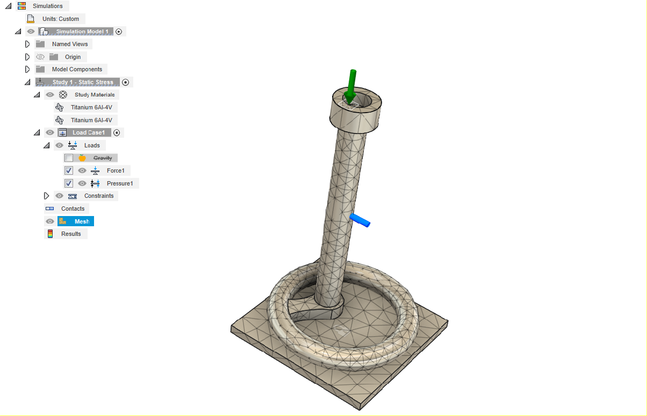
Figure 4. CAD model of the TORP with applied load and fixed support boundary conditions.

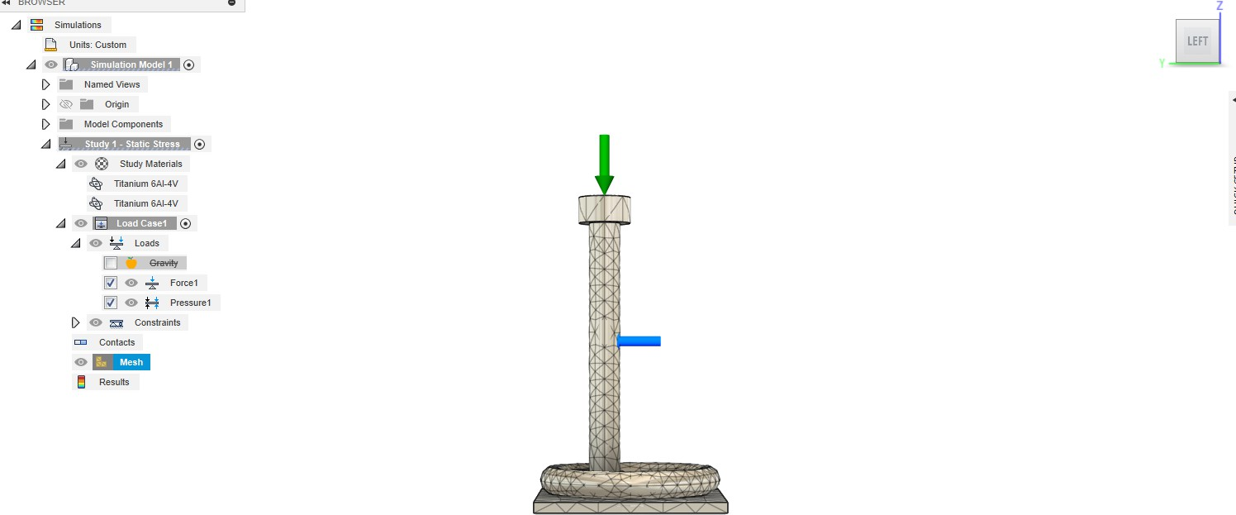

Figure 5. Mesh of the TORP prosthesis showing element distribution (9793 nodes, 5158 elements).
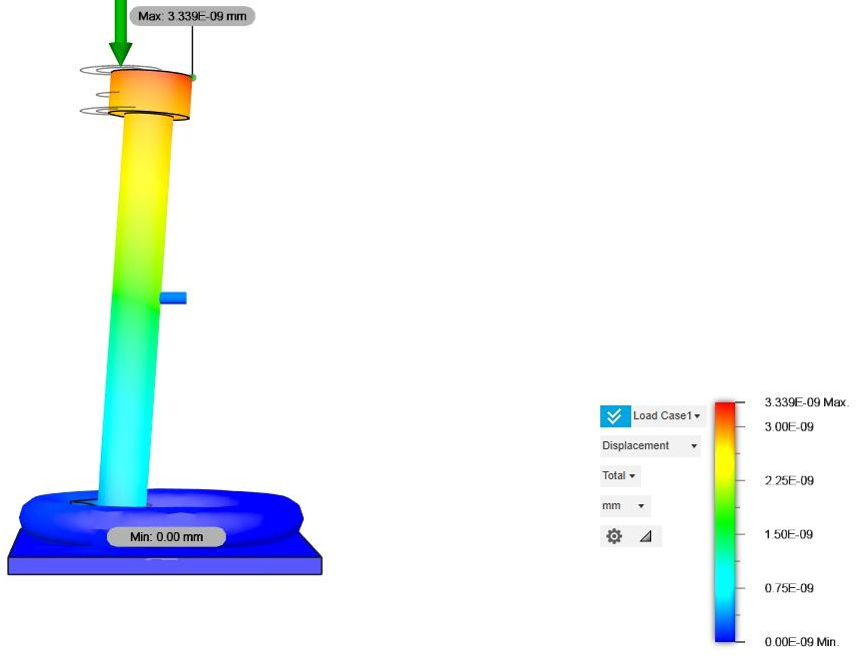

Figure 6. Total displacement distribution under acoustic-equivalent loading (maximum 3.339 × 10⁻⁹ mm).

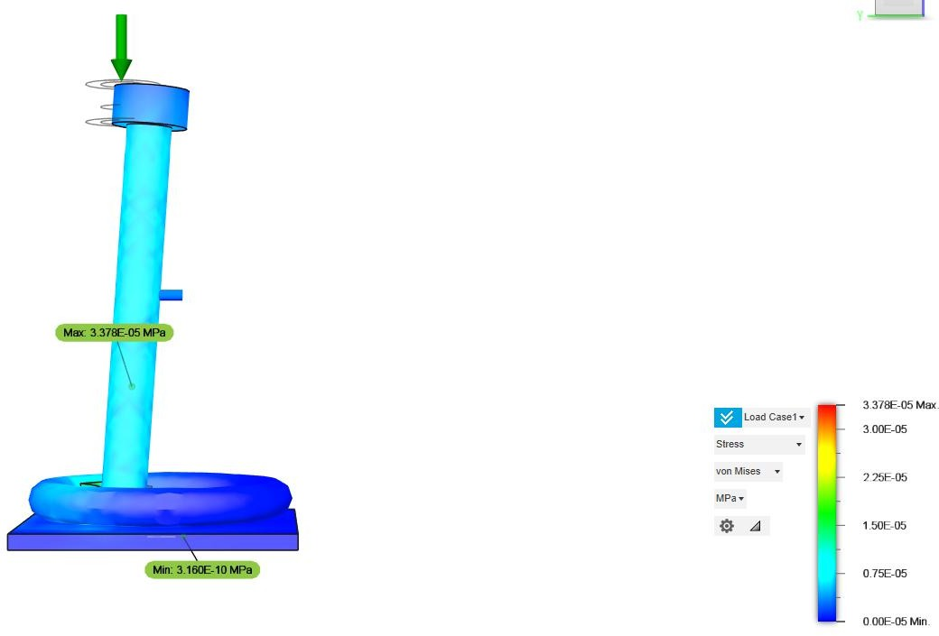

Figure 7. von Mises stress distribution across the TORP (maximum 3.378 × 10⁻⁵ MPa).
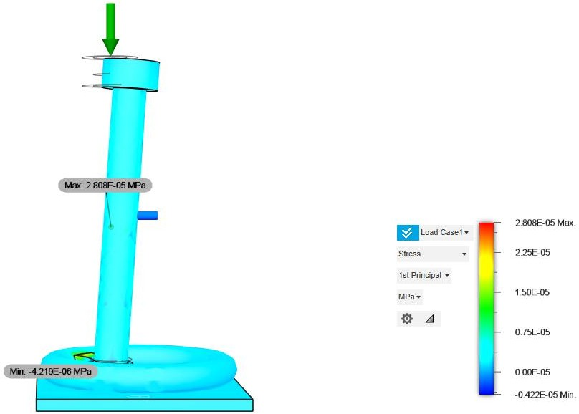

Figure 8. First principal stress distribution highlighting tensile regions.

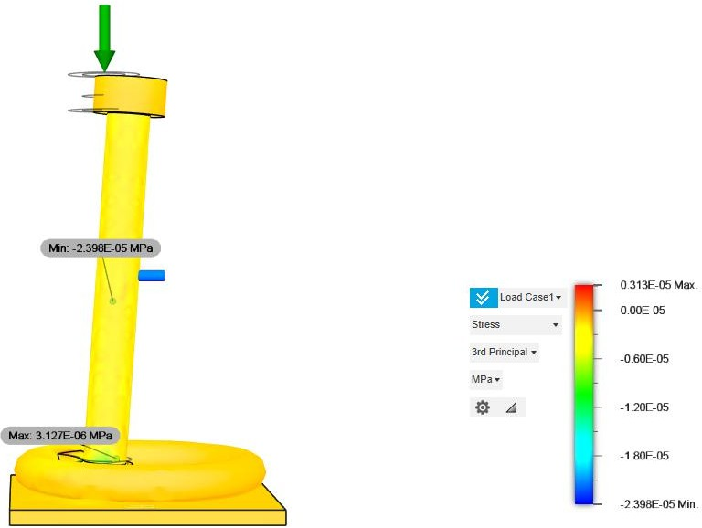

Figure 9. Third principal stress distribution highlighting compressive regions.
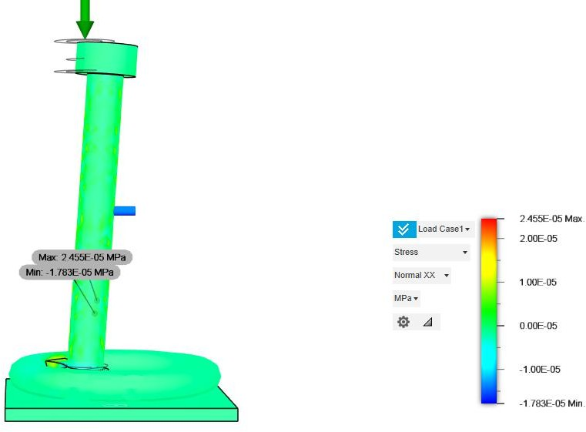

Figure 10. Normal stress distribution along X axis.

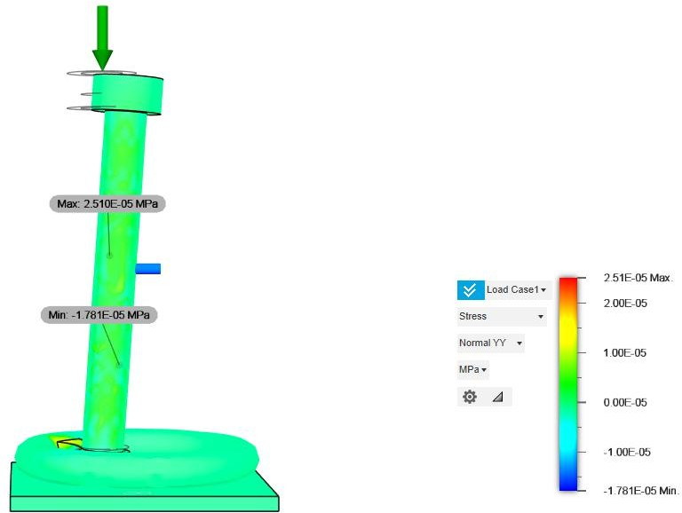

Figure 11. Normal stress distribution along Y axis.

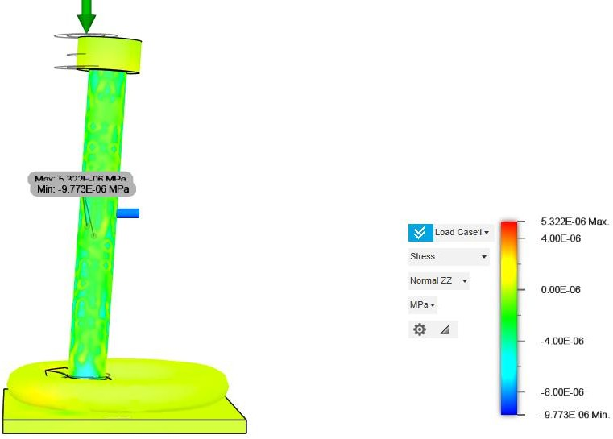

Figure 12. Normal stress distribution along Z axis.

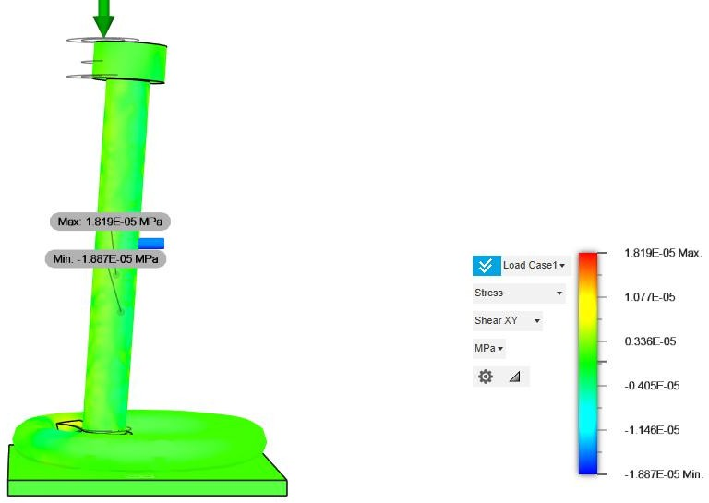

Figure 13. Shear stress distributions XY Plane

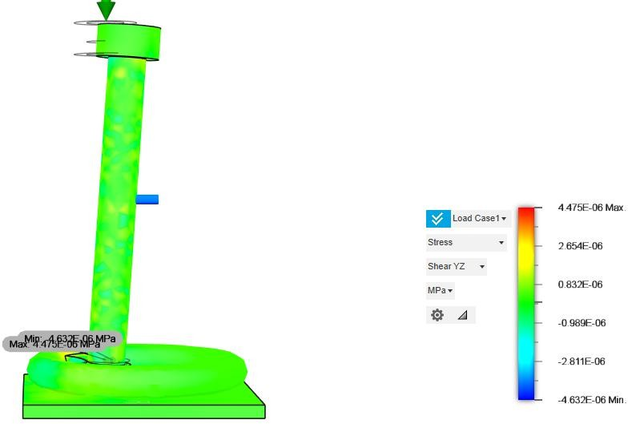

Figure 14. Shear stress distributions YZ Plane

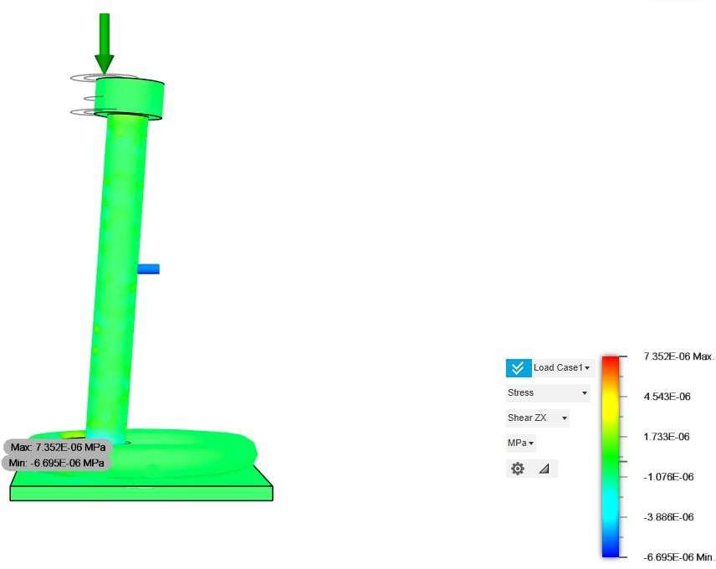

Figure 15. Shear stress distributions ZX Plane

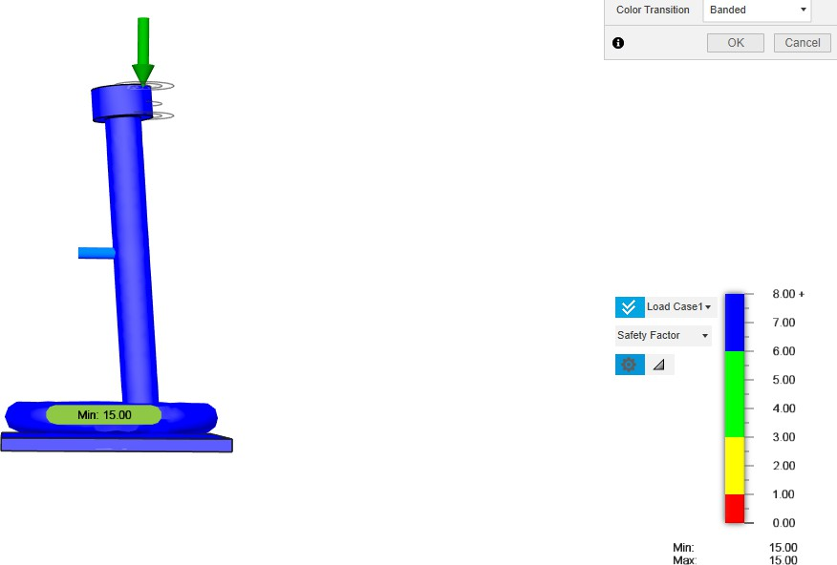

Figure 16. Safety factor distribution showing a minimum value of 15.0.

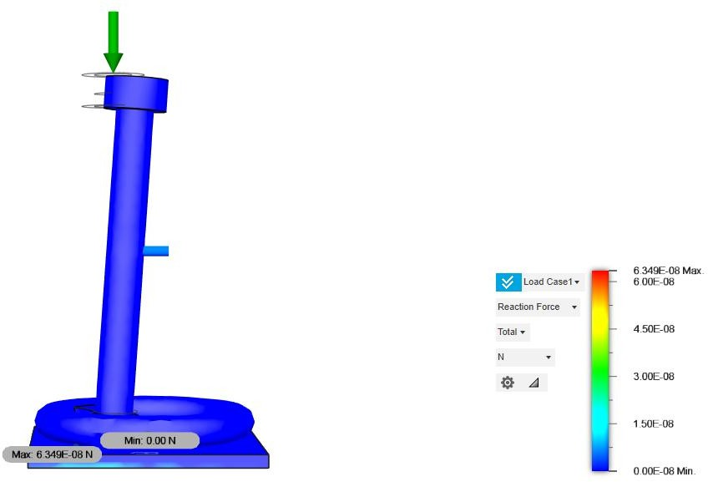

Figure 17. Reaction force distribution at the fixed footplate (maximum 6.349 × 10⁻⁸ N).

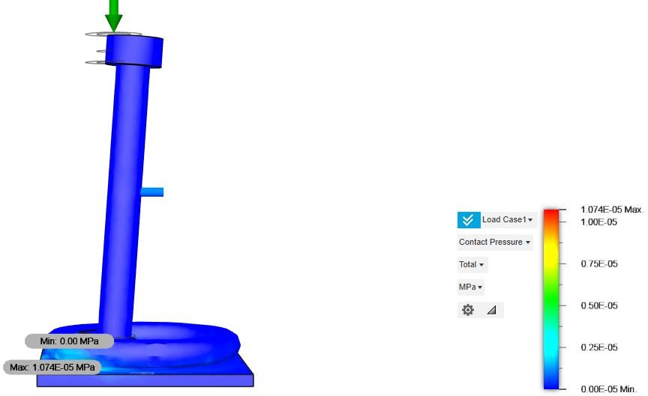

Figure 18. Contact pressure distribution at the footplate–support interface (maximum 1.074 × 10⁻⁵ MPa).

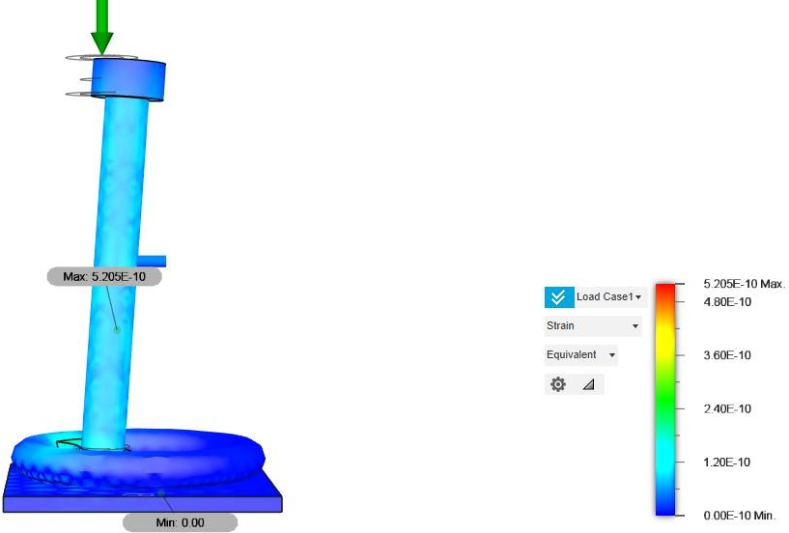

Figure 19. Equivalent strain distribution across the prosthesis body.

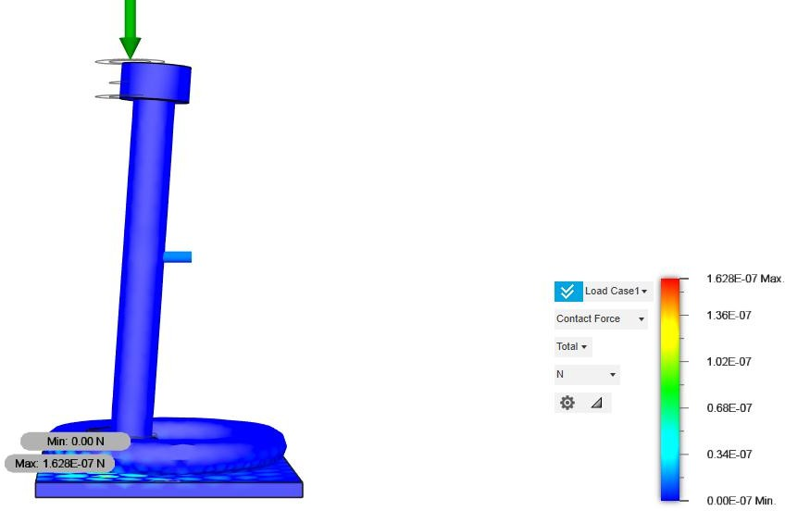

Figure 20. Contact force vector distribution at constraint regions.

MODAL ANALYSIS RESULTS
The modal frequency study was performed to evaluate the vibrational behavior of the TORP and to ensure that its natural frequencies lie outside the human auditory range (100–6000 Hz). The model was meshed with 10,927 nodes and 6,004 parabolic tetrahedral elements. The footplate was constrained in all translational degrees of freedom, while no external loads were applied. Eight eigenmodes were extracted using the Fusion 360 solver.
Key Findings:
    - Lowest Natural Frequency: 7427 Hz (Mode 1), safely above the auditory band.
    - Frequency Range of Modes: 7.4 kHz to 188.7 kHz.
    - Dominant Directional Participation:
      - Mode 1 → Strong Y-axis contribution (16.9).
      - Mode 2 → Strong X-axis contribution (15.7).
      - Mode 6 → Very high Z-axis contribution (21.8).
    - Normalized Modal Displacements: 0.00 to 1.00 across all modes, consistent with standard FEA scaling for mode shapes.

Mode | Frequency (Hz) | X  Participation | Y  Participation | Z  Participation | Dominant Axis
1 | 7427.21 | 0.0006 | 16.9159 | 0.0959 | Y-axis
2 | 10384.27 | 15.6905 | 0.0006 | 0.0000 | X-axis
3 | 56612.42 | 0.0000 | 3.2737 | 4.0052 | Z-axis
4 | 69116.61 | 4.4023 | 0.0001 | 0.0001 | X-axis
5 | 92024.34 | 0.0002 | 0.0017 | 0.0519 | Z-axis
6 | 92400.37 | 0.0001 | 0.4765 | 21.8270 | Z-axis
7 | 179898.41 | 0.0003 | 1.6240 | 0.7453 | Y-axis
8 | 188724.50 | 1.6765 | 0.0000 | 0.0002 | X-axis

Table 3. Modal Frequencies and Directional Participation Factors Interpretation:
- Modes 1 and 2 represent the lowest fundamental resonances (≈7–10 kHz), both above the normal hearing band.
- Higher modes (56–188 kHz) represent localized bending and twisting, which are clinically irrelevant but confirm the model’s structural stiffness.
- The dominance of single axes in most modes suggests that the prosthesis exhibits well- defined vibrational behavior without complex coupled oscillations in the speech frequency range.

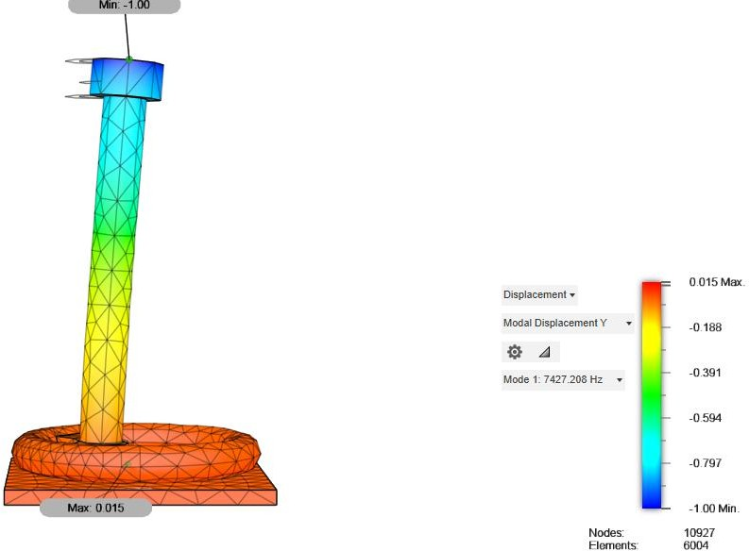

Figure 21. Mode 1 deformation shape at 7427 Hz, dominated by Y-axis participation.
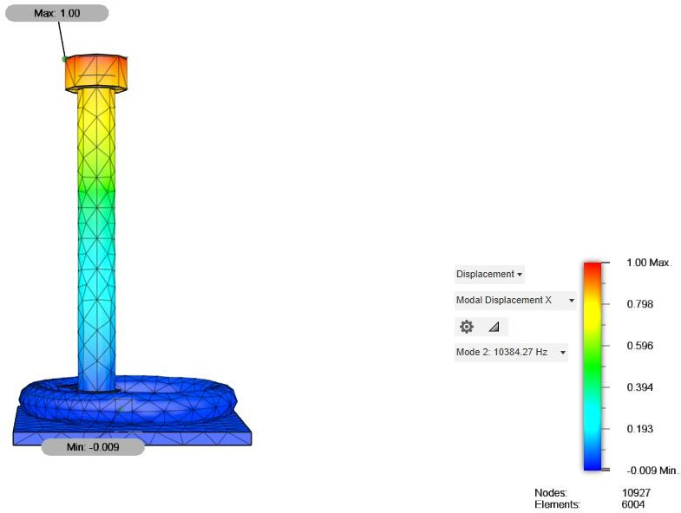

Figure 22. Mode 2 deformation shape at 10,384 Hz, dominated by X-axis participation.

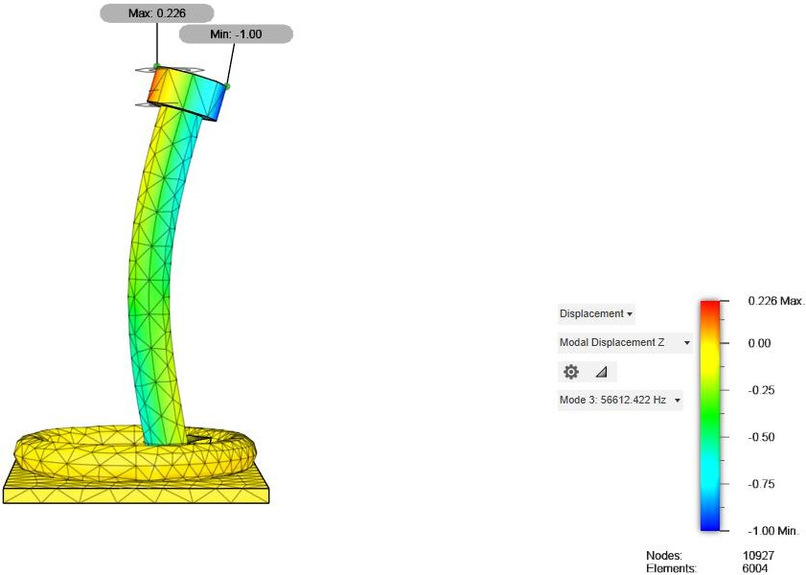

Figure 23. Mode 3 deformation shape at 56,612 Hz, dominated by Z-axis participation.

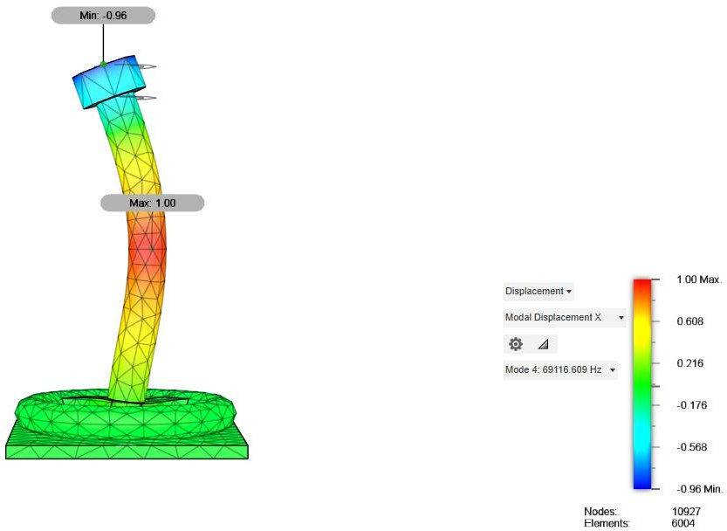

Figure 24. Mode 4 deformation shape at 69,116 Hz, dominated by X-axis participation.

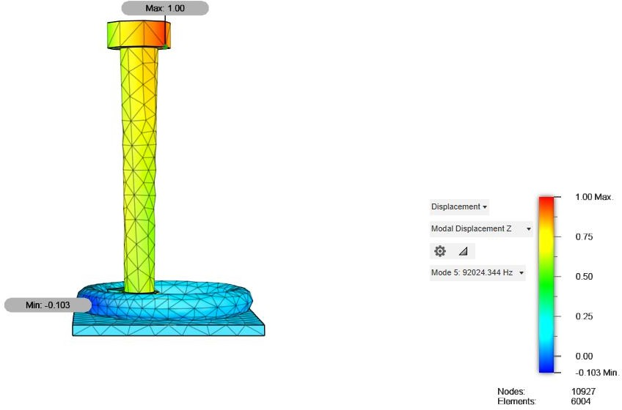

Figure 25. Mode 5 deformation shape at 92,024 Hz, dominated by Z-axis participation.
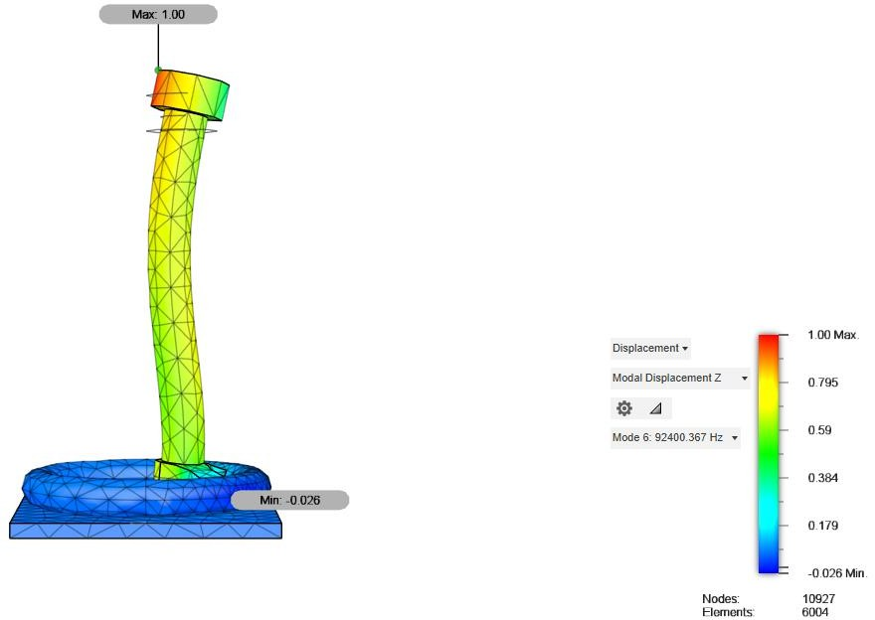

Figure 26. Mode 6 deformation shape at 92,400 Hz, strongly dominated by Z-axis participation

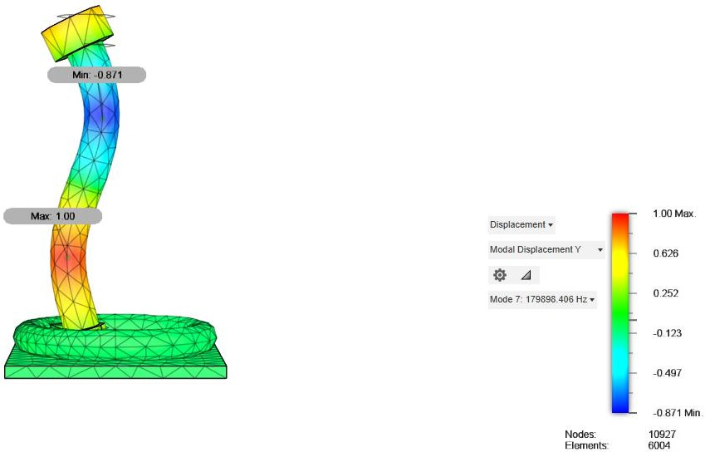

Figure 27. Mode 7 deformation shape at 179,898 Hz, dominated by Y-axis participation.

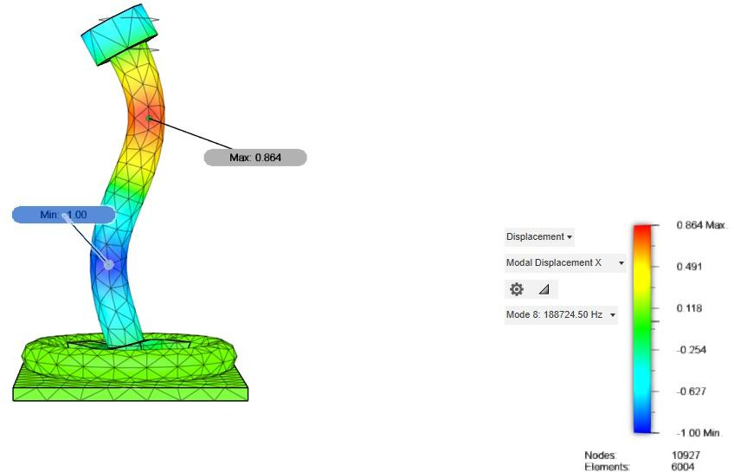

Figure 28. Mode 8 deformation shape at 188,724 Hz, dominated by X-axis participation.

CHAPTER 8

DISCUSSION

The findings of the computational analyses give solid support that the planned TORP is dynamically stable and structurally reliable.

Static Analysis:
The static stress analysis proved that the prosthesis undergoes minimal elastic deformation at acoustic-level loading. The largest displacement found was on the order of 10⁻⁹ mm, which is practically zero in the context of biological movement. Also, the highest von Mises stress that was recorded was 3.378 × 10⁻⁵ MPa, which is several orders of magnitude less than the yield strength of Ti-6Al-4V (≈882 MPa). This establishes the fact that under physiological forces, the TORP acts almost like a rigid body. The calculated safety factor of 15.0 also highlights the conservative margin of design. From a mechanical engineering point of view, such an extent of toughness guarantees that the implant will not experience failure or plastic deformation in its functional life.

Modal Analysis:
Modal analysis determined natural frequencies starting at around 7.4 kHz and going all the way up to almost 188 kHz. Crucially, these frequencies are well above the clinically significant auditory range of 100–6000 Hz. This means that the prosthesis will not vibrate under typical hearing situations, thus preventing distortion or exaggeration of sound transmission. The mode shapes that are observed are mostly higher-order bending and twisting of the shaft and head and are not prominent in normal everyday auditory performance. This result is especially promising as it shows that the combination of the geometry and material selection produces a stable vibrational response consistent with the clinical demands of ossicular reconstruction.

Design Implications:
Collectively, the analyses indicate that the TORP is statically safe under mechanical loads and dynamically stable under vibrational excitation. The synergy between the weight-efficient titanium alloy, compact geometry, and smooth transition in features leads to this desirable performance. This instills confidence that the prosthesis will efficiently transfer acoustic vibrations without compromising the structure or causing unwanted resonance.

CHAPTER 9

LIMITATIONS AND FUTURE CONSIDERATIONS

While the results of this study are promising, they must be interpreted with careful attention to the limitations inherent in the current methodology.

The present finite element simulations assumed linear elastic, isotropic behavior of the Ti-6Al- 4V alloy. In reality, implant-grade titanium alloys may exhibit microstructural anisotropy or nonlinear response under complex loading. Biological tissues surrounding the prosthesis, such as the tympanic membrane and middle-ear ligaments, were not modeled. Their absence limits the ability of the current simulations to capture realistic implant–tissue interactions.

Only conservative acoustic-equivalent loading conditions were applied, representing typical sound pressure levels. No consideration was given to extreme cases, such as sudden acoustic shocks, accidental trauma, or surgical misalignment. Similarly, cyclic fatigue loading—highly relevant for implants subject to long-term vibrational excitation—was excluded from the current scope.

The influence of body temperature fluctuations and the humid, saline environment of the middle ear was not considered. Corrosion, biofouling, and degradation mechanisms may alter the long-term performance of the implant and must be studied in future investigations.

Modal analysis in this work neglected damping. In practice, biological tissues provide significant damping, which would influence vibration amplitudes and resonance characteristics. Furthermore, acoustic–structural coupling between the prosthesis and cochlear fluids was not included, which could alter frequency response and energy transfer efficiency.

Future Considerations:

To address these limitations, several directions for future work are proposed:
- Incorporating nonlinear FEA models to account for contact, damping, and plasticity effects.
- Conducting mesh convergence and sensitivity studies to strengthen numerical reliability.
- Introducing acoustic–structural coupling simulations to model the interaction between prosthesis, tympanic membrane, and cochlear fluid.
- Performing fatigue and fracture analyses to assess long-term reliability under repeated cyclic loading.

- Fabricating prototypes using micro-manufacturing or additive manufacturing techniques, followed by in-vitro testing with artificial middle-ear setups.
- Advancing to animal models and clinical trials, in collaboration with otolaryngologists, to validate clinical safety and efficacy.
By addressing these considerations, future work can bridge the gap between computational validation and real-world clinical application of the TORP.

CHAPTER 10

ETHICAL, SAFETY, AND REGULATORY CONSIDERATIONS

The design and proposed application of a Total Ossicular Replacement Prosthesis (TORP) involve direct interaction with human patients. As such, ethical, safety, and regulatory frameworks must guide every stage of development, from design to deployment.

Ethical Responsibility
Patient safety is the foremost priority. Biocompatibility testing, in line with ISO 10993 standards, is essential to ensure that the implant does not cause toxicity, rejection, or inflammation. Ethical considerations extend to clinical trials, where informed consent, patient privacy, and transparency of results are mandatory. Researchers and manufacturers must disclose any potential conflicts of interest to maintain integrity in reporting.

Safety Protocols
The implant must comply with sterilization standards to eliminate infection risks. Manufacturing processes must adhere to Good Manufacturing Practices (GMP), ensuring quality control, traceability, and reproducibility. Post-market surveillance systems should be established to monitor implant performance and address potential complications.

Regulatory Pathways
Compliance with global and national medical device regulations is critical:
  - India: The Central Drugs Standard Control Organization (CDSCO) regulates implantable medical devices under the Medical Devices Rules (2017). TORPs fall under Class C or D devices, requiring extensive clinical evidence before approval.
  - United States: The U.S. Food and Drug Administration (FDA) classifies ossicular prostheses as Class II medical devices, requiring pre-market notification (510(k)) or pre-market approval depending on device novelty.
  - European Union: Compliance with EU MDR 2017/745 is necessary for CE marking, involving clinical evaluation, post-market surveillance, and notified body audits.

Clinical Trial Stages
Before clinical use, a staged approach is required:
- In-vitro testing with artificial ear models.
- In-vivo animal studies to assess biological response.
- Human clinical trials, conducted under strict ethical approval, to evaluate long-term safety, functionality, and patient-reported outcomes.

Societal and Accessibility Aspects
Beyond technical performance, accessibility and affordability of TORPs must be considered, particularly in resource-limited regions. Ethical responsibility includes designing cost- effective implants that can be made available to a broad patient population without compromising quality.

Research Transparency
All findings, including negative or inconclusive results, should be openly reported to avoid bias in the scientific record. Collaboration between engineers, clinicians, and regulatory experts will be essential to ensure safe translation of this technology into clinical practice.

CONCLUSION

This internship successfully accomplished the design and computational evaluation of a Total Ossicular Replacement Prosthesis (TORP) using Autodesk Fusion 360 and finite-element analysis. Under conservative acoustic-equivalent loading—a 5.0×10⁻⁵ N point force combined with a 1.0×10⁻⁶ MPa distributed pressure—the maximum von Mises stress remained at
~3.378×10⁻⁵ MPa, far below the Ti-6Al-4V yield strength, and the peak displacement was
~3.339×10⁻⁹ mm, indicating near-rigid behavior within physiological conditions. Modal analysis identified the first eight natural frequencies between ~7.4 kHz and ~188.7 kHz; critically, no modes occur in the 100–6000 Hz auditory band, reducing the risk of resonance- induced distortion during speech-relevant hearing. These results collectively support the mechanical safety and dynamic stability of the proposed design and provide a defensible basis for subsequent prototyping and experimental validation.

RECOMMENDATIONS AND FUTURE WORK

  - Material & standards alignment: Use Ti-6Al-4V ELI material data (ASTM F136) in the model or explicitly justify the library set used; document all properties in SI units with conversions.
  - Load case justification: Add SPL-based derivations or citations that map sound pressure to the applied force/pressure to demonstrate physiological relevance.
  - Convergence & sensitivity: Perform and report a mesh convergence study (global + local refinements at fillets) and a parameter sensitivity check on stem diameter and head/footplate thickness.
  - Harmonic/FRF analysis: Extend dynamics to harmonic response across 100–6000 Hz to confirm low steady-state amplitudes and phase behavior under sinusoidal excitation.
  - Manufacturing readiness: Compare CNC vs micro-AM tolerances; prepare a tolerance stack-up and surface-finish plan for the stem–head transitions to minimize stress risers.
  - Experimental validation: 3D-print a surrogate (scaled or full size) and validate with laser Doppler vibrometry; for metals, consider a simple cantilever surrogate to correlate modal frequencies before moving to the full geometry.
  - Biomechanical context: In future work, introduce contact/damping with middle-ear tissues and, where feasible, an acoustic–structural coupling step to approximate cochlear loading and verify transmission efficacy.

REFERENCES

- ASTM International, ASTM F136-13: Standard Specification for Wrought Titanium-6Aluminum- 4Vanadium ELI (Extra Low Interstitial) Alloy for Surgical Implant Applications (UNS R56401). West Conshohocken, PA: ASTM International, 2013.
- K. B. Hüttenbrink, “Middle ear implants: a review,” Acta Oto-Laryngologica, vol. 123, no. 2, pp. 123–129, 2003, doi: 10.1080/00016480310000950.
- P. S. Roland, C. Y. Wright, and T. Isaacson, “Clinical outcomes of titanium ossicular chain reconstruction prostheses,” Otolaryngology–Head and Neck Surgery, vol. 135, no. 5, pp. 731–737, Nov. 2006, doi: 10.1016/j.otohns.2006.05.739.
- International Organization for Standardization (ISO), ISO 10993-1: Biological evaluation of
medical devices – Part 1: Evaluation and testing within a risk management process, 5th ed., Geneva, Switzerland: ISO, 2018.
- International Organization for Standardization (ISO), ISO 14971: Medical devices – Application of risk management to medical devices, 3rd ed., Geneva, Switzerland: ISO, 2019.
- U.S. Food and Drug Administration (FDA), Guidance for Industry and FDA Staff: Class II Special Controls Guidance Document: Ossicular Chain Reconstruction Prostheses, Silver Spring, MD: U.S.
FDA, 2004. [Online]. Available: https://www.fda.gov/
- Central Drugs Standard Control Organization (CDSCO), Medical Devices Rules, Ministry of Health and Family Welfare, Government of India, New Delhi, 2017.
- Autodesk Inc., Autodesk Fusion 360 Simulation Documentation, Version 2.603.1.52. San Rafael, CA: Autodesk, 2025.

